Association of oil spill cleanup-related hydrocarbon exposure with incident hypertension up to 11 years after exposure in the Gulf Long-term Follow-up Study

Opal P. Patel, Jessie K. Edwards, Anna M. Kucharska-Newton, Eric A. Whitsel, Kate Christenbury, W. Braxton Jackson II, Kaitlyn G. Lawrence, Patricia A. Stewart, Mark R. Stenzel, Lawrence S. Engel*, Dale P. Sandler* (*co-senior authors)

Supplementary Material

Supplementary Table 1: Distribution of cumulative daily maximum exposure among GuLF Study participants (N=18,340)
Parts per billion | Minimum | Q2 cut point | Q3 cut point | Q4 cut point | Maximum
Benzene | 0.01 | 64.90 | 314.58 | 960.88 | 9,863.37
Toluene | 0.12 | 238.14 | 1,266.39 | 3,649.35 | 26,724.55
Ethylbenzene | 0.01 | 56.47 | 249.49 | 749.93 | 8,129.90
Xylene | 1.58 | 673.88 | 1,712.19 | 4,140.37 | 24,935.65
n-Hexane | 0.06 | 111.51 | 527.48 | 2,506.56 | 90,157.50

Supplementary Table 2: Characteristics of GuLF Study participants at enrollment and the first and second follow-up interviews
 | GuLF Study Visitª
Characteristic | Enrollment | First Follow-up | Second Follow-up
 | n=18,619 | n=12,604  (67.7%) | n=8,512  (45.7%)
 | Mean (SD) | Mean (SD) | Mean (SD)
Age at enrollment (continuous) | 40.0 (12.1) | 41.3 (12.2) | 42.0 (12.2)
 | n (%) | n (%) | n (%)
Age at enrollment
<40 years | 9,572 (51.4) | 5,860 (46.5) | 3,751 (44.1)
≥40 years | 9,047 (48.6) | 6,744 (53.5) | 4,761 (55.9)
Sex
Male | 15,211 (81.7) | 10,198 (80.9) | 6,768 (79.5)
Female | 3,408 (18.3) | 2,406 (19.1) | 1,744 (20.5)
Education
Less than high school | 2,786 (15.0) | 1,726 (13.7) | 908 (10.7)
High school diploma/GED | 5,484 (29.5) | 3,490 (27.7) | 2,115 (24.8)
Some college/2 year degree | 5,593 (30.0) | 3,772 (29.9) | 2,581 (30.3)
4 year college graduate or more | 4,756 (25.5) | 3,616 (28.7) | 2,908 (34.2)
Race and ethnicity
Non-Hispanic White | 12,013 (64.5) | 8,273 (65.6) | 5,994 (70.4)
Non-Hispanic Black | 4,149 (22.3) | 2,694 (21.4) | 1,505 (17.7)
Non-Hispanic Other | 1,138 (6.1) | 799 (6.3) | 500 (5.9)
Hispanic White | 417 (2.2) | 284 (2.3) | 190 (2.2)
Hispanic Black | 72 (0.4) | 47 (0.4) | 27 (0.3)
Hispanic Other | 830 (4.5) | 507 (4.0) | 296 (3.5)
Smoking status
Never smoker | 9,120 (49.6) | 6,365 (51.0) | 4,525 (53.6)
Former smoker | 3,626 (19.7) | 2,539 (20.4) | 1,830 (21.7)
Light current smoker | 3,807 (20.7) | 2,396 (19.2) | 1,418 (16.8)
Heavy current smoker | 1,837 (10.0) | 1,172 (9.4) | 665 (7.9)
BMI (kg/m²)^{b}
<18.5 | 146 (0.8) | 101 (0.8) | 62 (0.7)
18.5-24.9 | 5,510 (29.6) | 3,648 (28.9) | 2,438 (28.6)
25-29.9 | 7,823 (42.0) | 5,312 (42.1) | 3,667 (43.1)
≥30 | 5,140 (27.6) | 3,543 (28.1) | 2,345 (27.5)
Neighborhood Disadvantage^{c}
Low | 13,747 (73.8) | 9,372 (74.4) | 6,574 (77.2)
High | 4,872 (27.2) | 3,232 (26.5) | 1,938 (23.5)
Risk period^{d}
0-1.9 years | 6,333 (34.0) | 1,770 (14.0) | 1,049 (12.3)
2-3.9 years | 4,123 (22.1) | 3,545 (28.1) | 509 (6.0)
4-5.9 years | 1,444 (7.8) | 1,338 (10.6) | 494 (5.8)
≥6 years | 6,719 (36.1) | 5,951 (47.2) | 6,460 (75.9)
ªEnrollment interview occurred from March 2011 to March 2013. First follow-up interview occurred from May 2013 to April 2016. Second follow-up interview occurred from November 2017 to July 2021.
^{b}BMI = body mass index; calculated as weight in kilograms divided by height in meters squared (kg/m²) as reported at enrollment.
^{c}Neighborhood disadvantage defined using the 2013 Area Deprivation Index (ADI) for low (US percentile 1-75th) and high (US percentile 76-100th) neighborhood disadvantage.
^{d}The risk period (years) was the time between each participant’s end of cleanup date to the first self-reported hypertension diagnosis date, death from other causes, and end of cohort follow-up.

Supplementary Table 3: Spearman correlation coefficients between BTEX-H oil spill chemicals among GuLF Study participants (N=18,340)
Cumulative maximum | Benzene | Toluene | Ethylbenzene | Xylene | n-Hexane
Benzene | 1.0
Toluene | 0.95 | 1.0
Ethylbenzene | 0.94 | 0.93 | 1.0
Xylene | 0.90 | 0.91 | 0.95 | 1.0
n-Hexane | 0.88 | 0.89 | 0.91 | 0.87 | 1.0

Supplementary Table 4: Associations between cumulative maximum exposure to BTEX-H chemicals and hazard of hypertension among DWH disaster oil spill response and cleanup workers (N=18,619)
Exposureª | Q1^{b} | Q2 |  | Q3 |  | Q4 |  | p-trend
 |  | HR | 95% CI | HR | 95% CI | HR | 95% CI
total BTEX-H | Ref | 1.09 | (1.00, 1.20) | 1.17 | (1.07, 1.29) | 1.31 | (1.19, 1.44) | <0.01
Benzene | Ref | 1.15 | (1.05, 1.26) | 1.22 | (1.11, 1.34) | 1.30 | (1.18, 1.43) | <0.01
Toluene | Ref | 1.17 | (1.07, 1.28) | 1.16 | (1.06, 1.27) | 1.35 | (1.23, 1.49) | <0.01
Ethylbenzene | Ref | 1.08 | (0.99, 1.18) | 1.20 | (1.09, 1.31) | 1.30 | (1.18, 1.42) | <0.01
Xylene | Ref | 1.02 | (0.93, 1.11) | 1.14 | (1.04, 1.25) | 1.27 | (1.16, 1.39) | <0.01
n-Hexane | Ref | 1.10 | (1.01, 1.21) | 1.15 | (1.05, 1.26) | 1.33 | (1.21, 1.45) | <0.01
 |  | HR | 95% CI
BTEX-H mixture^{c} |  | 1.10 | (1.07, 1.14)
ªCumulative exposure to each BTEX-H chemical measured in ppb-days, calculated as the sum of the daily maximum exposure estimates. Total BTEX-H calculated as a sum of the individual BTEX-H ppb values.
^{b}Multivariable Cox proportional hazards regression models adjusted for age (with quadratic splines at ages 50 and 60 years), sex, self-reported race, Hispanic ethnicity, highest educational attainment, BMI, and residential proximity to the oil spill.
^{c}Quantile g-computation estimates for hazard of incident hypertension per one quartile increase in cumulative maximum exposure to all crude oil chemicals (BTEX-H).

Supplementary Table 5: Associations between cumulative average exposure to BTEX-H chemicals and hazard of hypertension among DWH disaster oil spill response and cleanup workers (N=18,619)
Exposureª | Q1^{b} | Q2 |  | Q3 |  | Q4 |  | p-trend
 |  | HR | 95% CI | HR | 95% CI | HR | 95% CI
total BTEX-H | Ref | 1.06 | (0.97, 1.16) | 1.12 | (1.03, 1.23) | 1.20 | (1.10, 1.32) | <0.01
Benzene | Ref | 1.17 | (1.07, 1.28) | 1.22 | (1.12, 1.34) | 1.19 | (1.08, 1.30) | <0.01
Toluene | Ref | 1.11 | (1.01, 1.21) | 1.17 | (1.07, 1.29) | 1.18 | (1.07, 1.30) | <0.01
Ethylbenzene | Ref | 1.11 | (1.01, 1.22) | 1.14 | (1.04, 1.25) | 1.23 | (1.12, 1.35) | <0.01
Xylene | Ref | 1.07 | (0.98, 1.16) | 1.06 | (0.97, 1.16) | 1.19 | (1.09, 1.31) | <0.01
n-Hexane | Ref | 1.10 | (1.00, 1.20) | 1.13 | (1.03, 1.24) | 1.23 | (1.12, 1.34) | <0.01
 |  | HR | 95% CI
BTEX-H mixture^{c} |  | 1.07 | (1.04, 1.10)
ªCumulative exposure to each BTEX-H chemical measured in ppb-days, calculated as the sum of the daily average exposure estimates. Total BTEX-H calculated as a sum of the individual BTEX-H ppb values.
^{b}Multivariable Cox proportional hazards regression models adjusted for age (with quadratic splines at ages 50 and 60 years), sex, self-reported race, Hispanic ethnicity, highest educational attainment, BMI, and residential proximity to the oil spill.
^{c}Quantile g-computation estimates for hazard of incident hypertension per one quartile increase in cumulative average exposure to all crude oil chemicals (BTEX-H).

Supplementary Table 6: Results of associations between cumulative maximum total BTEX-H exposure and incident hypertension in main versus sensitivity analyses
Modelª | Q1 | Q2 | 95% CI | Q3 | 95% CI | Q4 | 95% CI
Main adjusted model^{b} | Ref | 1.09 | (1.00,1.20) | 1.17 | (1.07,1.29) | 1.31 | (1.19,1.44)
Excluded discrepant/no hypertension diagnosis date | Ref | 1.02 | (0.91,1.14) | 1.14 | (1.02,1.28) | 1.25 | (1.12,1.41)
Discrete time assumption for hypertension diagnosis date | Ref | 1.14 | (1.03,1.27) | 1.24 | (1.12,1.37) | 1.47 | (1.32,1.63)
Started risk period at enrollment | Ref | 1.14 | (1.01,1.28) | 1.26 | (1.11,1.42) | 1.33 | (1.17,1.51)
Excluded workers with any cleanup-related PM_{2.5} exposure | Ref | 1.10 | (1.00,1.20) | 1.14 | (1.04,1.25) | 1.29 | (1.17,1.43)
Restricted to never smokers at enrollment | Ref | 1.18 | (1.03,1.35) | 1.17 | (1.02,1.34) | 1.39 | (1.21,1.60)
Inverse probability of censoring weighting | Ref | 1.09 | (0.99, 1.19) | 1.18 | (1.07, 1.30) | 1.31 | (1.18, 1.44)
ªCumulative exposure to each BTEX-H chemical measured in ppb-days, calculated as the sum of the daily maximum exposure estimates. Total BTEX-H calculated as a sum of the individual BTEX-H ppb values.
^{b}Main Cox proportional hazards regression models adjusted for age (with linear spline at ages 50 and 60 years), sex, self-reported race, Hispanic ethnicity, highest educational attainment, diabetes prior to the spill, and residential proximity to the oil spill.

Supplementary Table 7: Results of quantile g-computation estimates for hazard of incident hypertension per one quartile increase in cumulative maximum exposure to the BTEX-H chemical mixture in main versus sensitivity analyses
 | BTEX-H Mixture
Modelª | HR | 95% CI
Main adjusted model^{b} | 1.10 | (1.07,1.14)
Excluded discrepant/no hypertension diagnosis date | 1.10 | (1.05,1.14)
Discrete time assumption for hypertension diagnosis date | 1.14 | (1.10,1.19)
Started risk period at enrollment | 1.12 | (1.07,1.17)
Excluded workers with any cleanup-related PM_{2.5} exposure | 1.09 | (1.06,1.13)
Restricted to never smokers at enrollment | 1.12 | (1.07,1.18)
ªCumulative exposure to each BTEX-H chemical measured in ppb-days, calculated as the sum of the daily maximum exposure estimates.
^{b}Main Cox proportional hazards regression models adjusted for age (with linear spline at ages 50 and 60 years), sex, self-reported race, Hispanic ethnicity, highest educational attainment, BMI, and residential proximity to the oil spill.

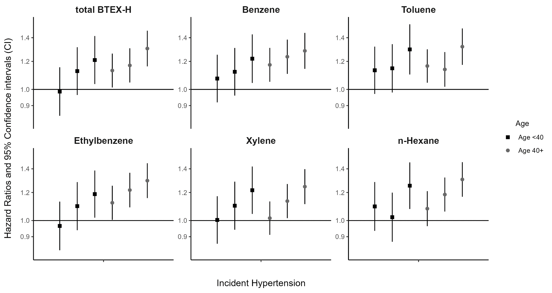

Supplementary Figure 1: Associations between cumulative maximum exposure to BTEX-H chemicals and hazard of hypertension among DWH disaster oil spill response and cleanup workers – stratified by age (<40 vs. ≥40 years)

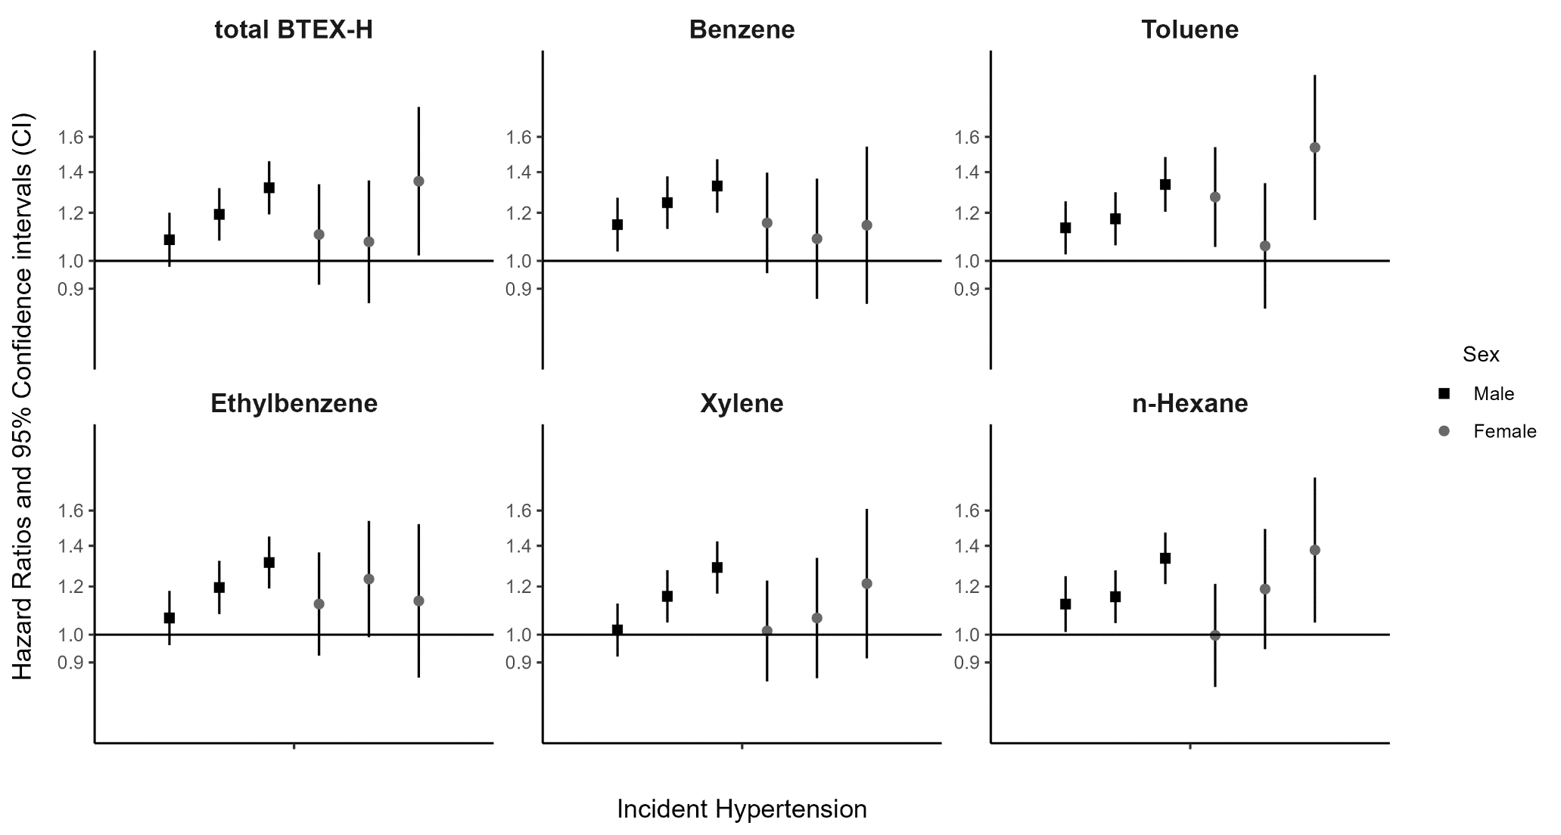

Supplementary Figure 2: Associations between cumulative maximum exposure to BTEX-H chemicals and hazard of hypertension among DWH disaster oil spill response and cleanup workers – stratified by sex (male vs. female)

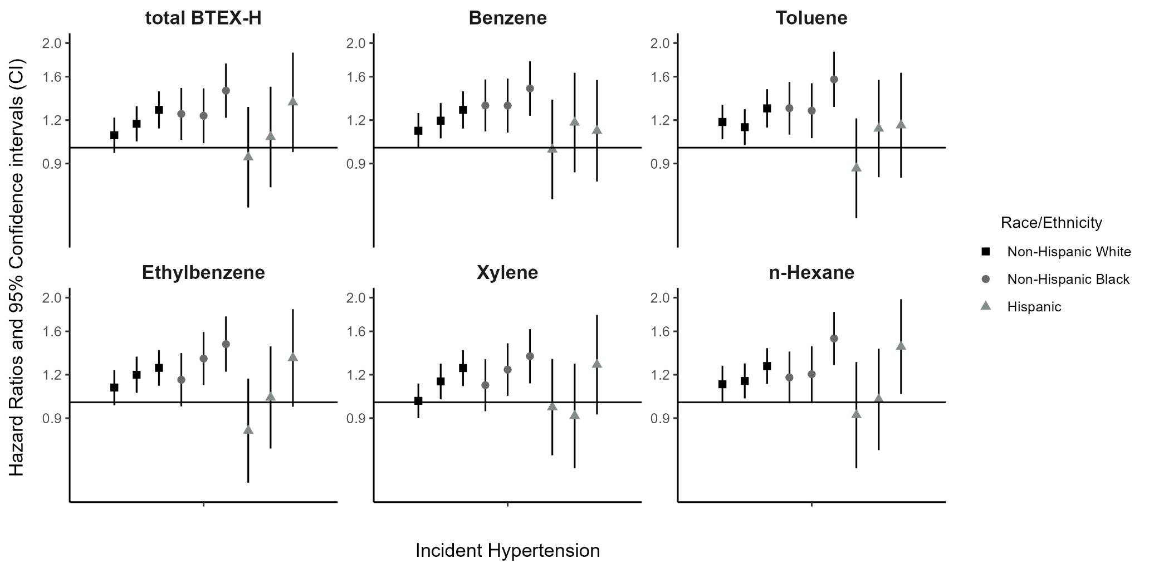

Supplementary Figure 3: Associations between cumulative maximum exposure to BTEX-H chemicals and hazard of hypertension among DWH disaster oil spill response and cleanup workers – stratified by race (Non-Hispanic White, Non-Hispanic Black, and Hispanic)

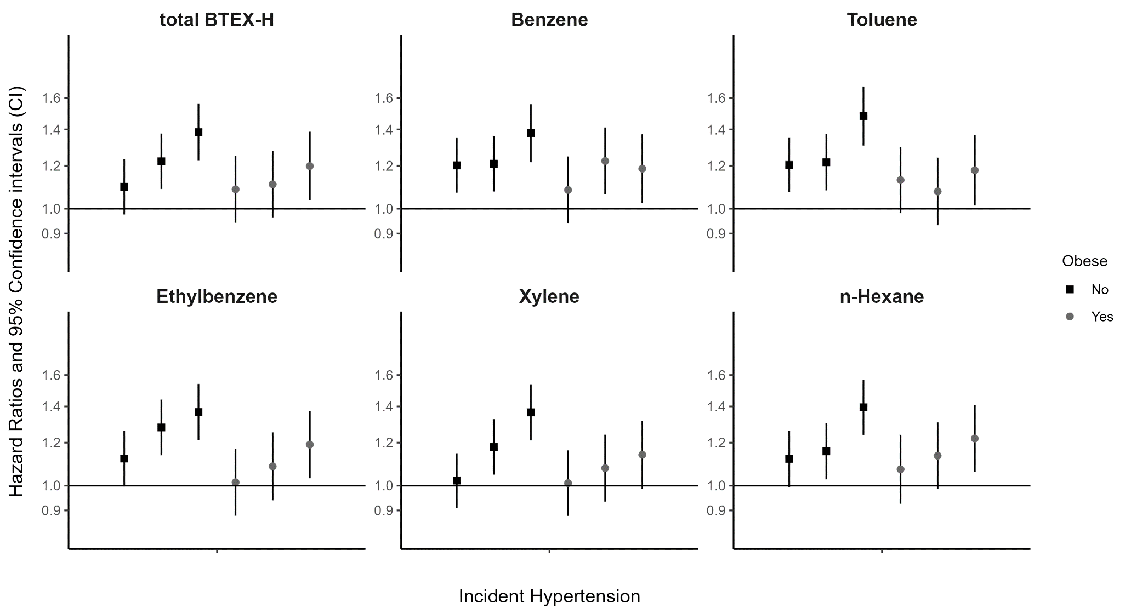

Supplementary Figure 4: Associations between cumulative maximum exposure to BTEX-H chemicals and hazard of hypertension among DWH disaster oil spill response and cleanup workers – stratified by obesity (non-obese vs. obese)

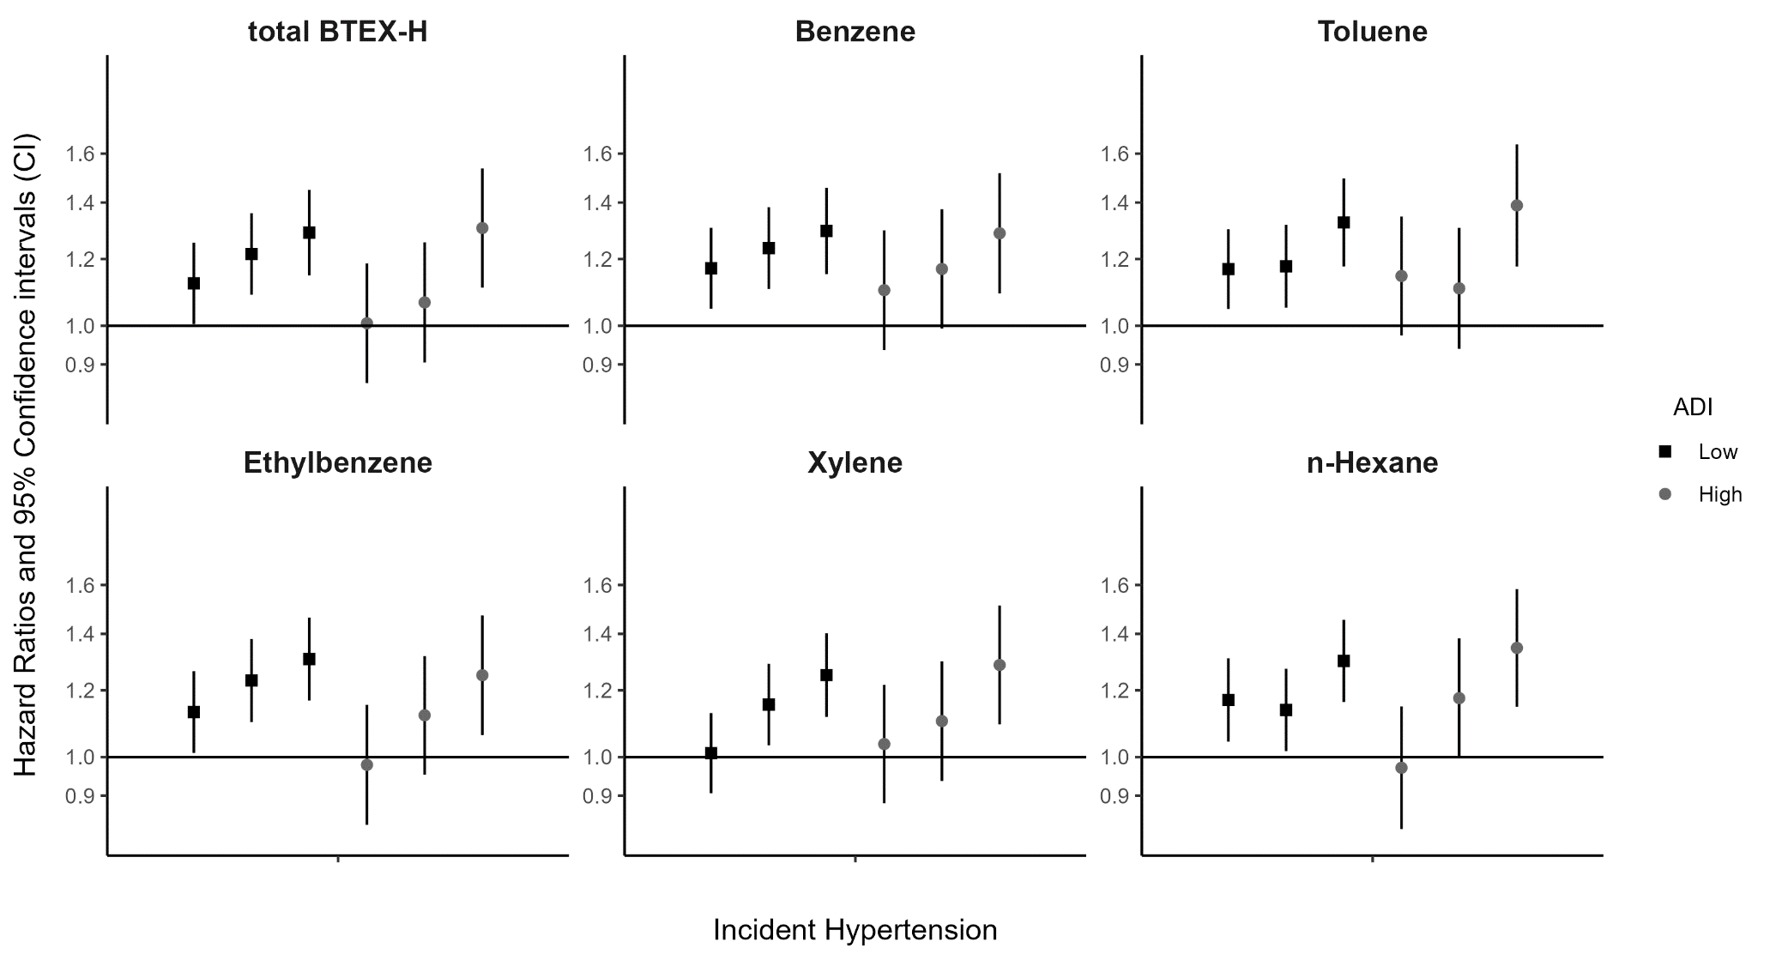

Supplementary Figure 5: Associations between cumulative maximum exposure to BTEX-H chemicals and hazard of hypertension among DWH disaster oil spill response and cleanup workers – stratified by Area Deprivation Index (low vs. high neighborhood disadvantage)

