Annexes

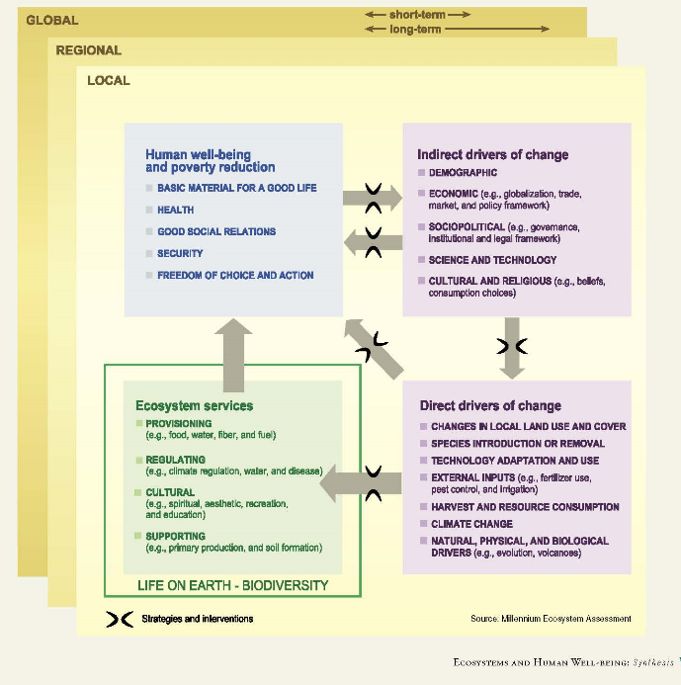
Annex 1: Conceptual Framework of Interactions between Biodiversity, Ecosystem Services,
Human Well-being, and Drivers of Change
Sources: MEA (2005)

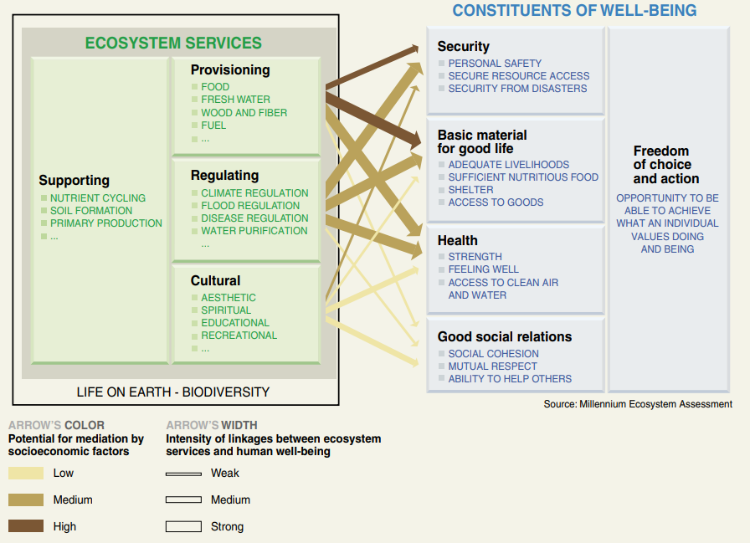
Annex 2: Linkages between Ecosystem Services and Human Well-being
Source: MEA (2005)

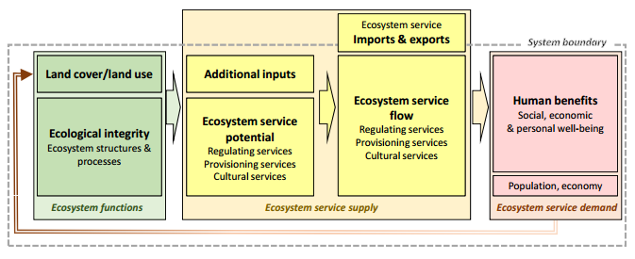
Annex 3: Conceptual model showing relations of ecosystem functions, services, and benefits
Sources: Burkhard et al., 2014

Annex 4: Pie chart for Lake Hawassa Basin LULC Type and area coverage in percent (2007)
Source: MoWE, 2007

